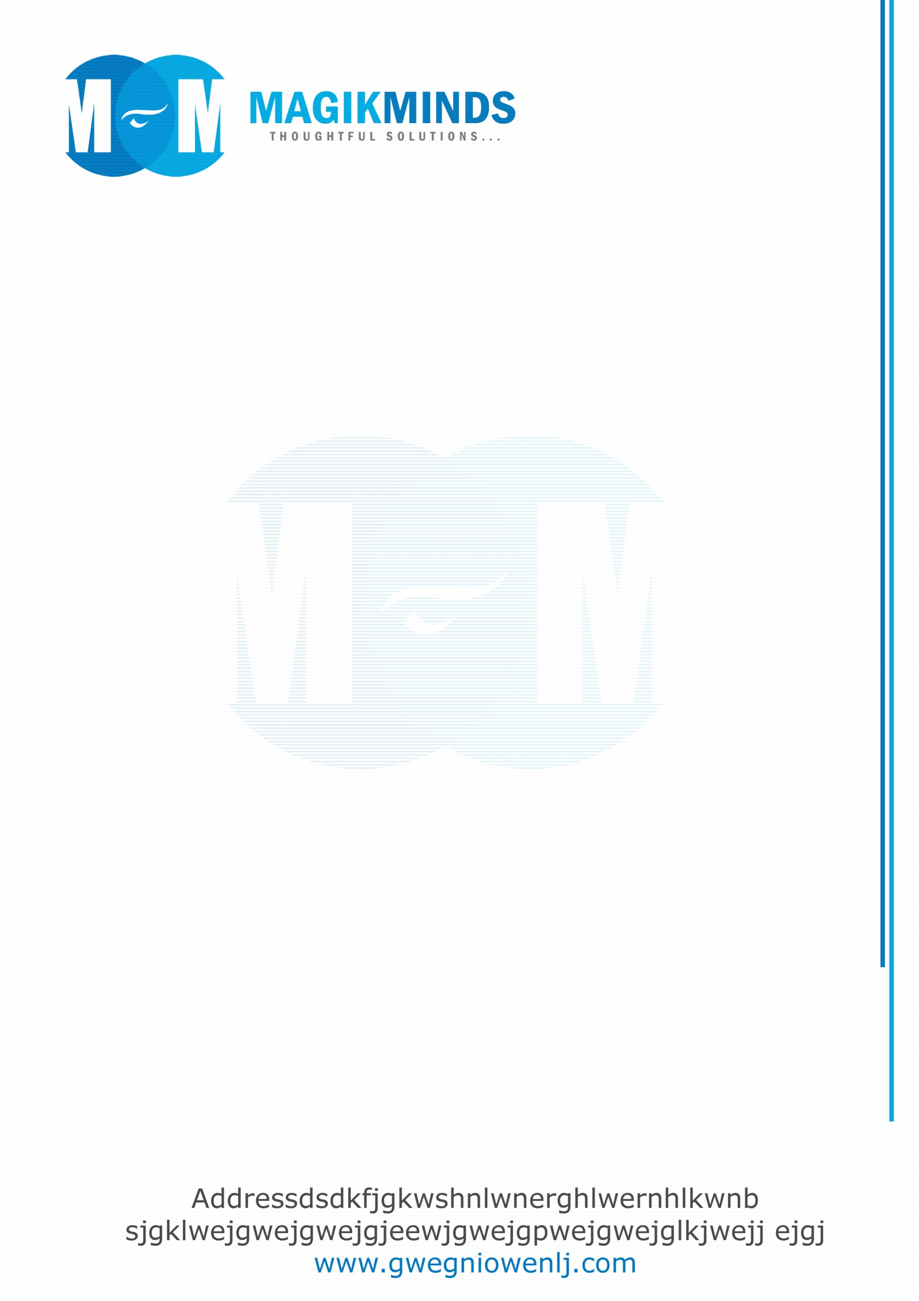

User Story & Acceptance Criteria

Formsz

Marbles Feature

4/19/2016

MagikMinds Software Services Pvt. Ltd.

M.L.Surendra

**User Story 1:**

As a Root Admin, I want to create Group Admins.

**Acceptance criteria:**

1. If I am a root admin, I can create Group admins.

2. I can create Group admins by entering following information about User: a. Name, b. User name

c. Email address, d. Mobile number.

3. When Group admin is created, Login credentials will be mailed to that admin automatically.

4. I cannot create the Group user without Email Id.

5. I can view List of group admins and can delete the admins.

**User Story 2:**

As a Root admin, I want to create Templates.

**Acceptance criteria:**

1. As a root admin, I can create Templates.

2. I can create Templates by using Field labels and Field settings, by drag and drop the fields template

is created.

3. I can view, Edit and Delete the created templates.

4. I can Copy and Rename the created templates.

**User Story 3:**

As a Root admin, I want map all the Admins to a Admin group.

**Acceptance criteria:**

1. If I am a root admin, I can Map and Unmap the admins to admin group.

2. By selecting list of admins and Admin group, I can map the particular admins to one group.

3. Similarly by selecting particular group and admins, I can unmap the admins.

**User Story 4:**

As a Group admin, I want to login.

**Acceptance criteria:**

1.If I am an Admin, I can login into an account with valid credentials created by root admin.

2. For invalid credentials, I cannot login.

3. I can see the Invalid user name/ Password notification for unsuccessful login.

**User Story 5:**

As a Group admin, I want to create users.

**Acceptance criteria:**

1. When I am login into account, I can create the new users.

2. I can create User, by entering following information about User: a. Name, b. User name

c. Email address, d. Mobile number.

3. When User created, Login credentials will be mailed to that user automatically.

4. As an admin, I cannot create the user without user Email Id.

5. I can view list of users and can delete the users.

**User Story 6:**

As a Group admin, I want create new form.

**Acceptance criteria**:

1. As a group admin, I can create new form.

2. I can create form by using Field labels and Field settings, by drag and drop the fields form

is created.

3. I can view, Edit, Copy, Rename and Delete the created forms.

4. I can view the submitted records in Grid view or in tabular view.

5. I can export the records to mail by using Export option.

**User Story 7:**

As a Group admin, I want import the template.

**Acceptance criteria:**

1.As a group admin, I can Import the template which are created by root admin.

2. I can rename and can edit the imported template.

3. I cannot delete the templates.

**User Story 8:**

As a Group admin, I want re-assign the records.

**Acceptance criteria:**

1.I can able to re-assign the records to submitted user with comments.

2. By that an alert should be displayed to the corresponding users.

3. I cannot re-assign the records without entering comments.

**User Story 9:**

As a Group admin, I want publish and unpublished the form.

**Acceptance criteria:**

1. As an admin, I can publish the form for certain users only.

2. Similarly I can unpublished the form for certain users.

3. By that an alert should be displayed to the corresponding users.

**User story 10:**

As an admin, I want recover my Password.

**Acceptance criteria:**

1.Click on forgot password and enter the registered mail Id.

2. New password link is send to registered mail.

3. By click on link, user can create new password.